10. StyleHub, a premier online fashion retailer, introduces an e-commerce platform offering clothing, footwear and accessories for men, women and children, with categories such as casual wear, formal attire and seasonal collections. Key functionalities include user registration and login, search and filtering, detailed product descriptions with images, reviews and size guides, secure payments, order tracking, and an easy return and exchange policy. Customers can create wish lists, receive style recommendations and enjoy flash sales. Products are logically categorized with popular categories first, and categories and subcategories are shown on the home page. The administrator can add items, remove items, modify prices, update descriptions and view information about each customer who checks out.
AIM
To design a simple Online Fashion Store webpage where customers can browse products by category, search items, select a size, add items to a wish list and shopping cart, check out with flash-sale prices, check the order status, and request a return or exchange.
HTML CODE
<!DOCTYPE html>
<html lang="en">
<head>
<meta charset="UTF-8">
<meta name="viewport" content="width=device-width, initial-scale=1">
<title>StyleHub Online Fashion Store</title>
<style>
body { font: 16px Arial, sans-serif; max-width: 650px; margin: 40px auto; padding: 20px; color: #222; background: #faf5ff; }
h1 { color: #7b2cbf; }
section { border: 1px solid #e0cdf3; background: #fff; border-radius: 8px; padding: 20px; margin: 20px 0; }
input, select, button { padding: 10px; margin: 6px 0; width: 100%; box-sizing: border-box; }
button { background: #7b2cbf; color: #fff; border: 0; border-radius: 6px; cursor: pointer; }
.item { display: flex; justify-content: space-between; align-items: center; border-bottom: 1px solid #eee; padding: 8px 0; }
.item select, .item button { width: auto; margin: 0 0 0 6px; padding: 6px 10px; }
button:disabled { background: #aaa; cursor: not-allowed; }
.sale { color: #c62828; font-weight: bold; }
.old { text-decoration: line-through; color: #888; }
.ok { color: #146c43; font-weight: bold; }
</style>
</head>
<body>
<h1>StyleHub Fashion</h1>

<section>
<h2>Browse Collection (Flash Sale: 20% OFF)</h2>
<select id="cat" onchange="showProducts()">
<option>All</option><option>Men</option><option>Women</option><option>Kids</option>
</select>
<input id="q" placeholder="Search clothing, footwear, accessories..." oninput="showProducts()">
<div id="products"></div>
<p id="wishMsg"></p>
</section>

<section>
<h2>Shopping Cart</h2>
<div id="cart"></div>
<p><b>Total: Rs.<span id="total">0</span></b></p>
<button onclick="checkout()">Checkout</button>
<p id="orderResult"></p>
</section>

<section>
<h2>Order Status / Return</h2>
<input id="oid" placeholder="Enter order ID" maxlength="6">
<button onclick="checkOrder()">Check Status</button>
<button onclick="returnOrder()" style="background:#555">Return / Exchange</button>
<p id="statusResult"></p>
<small>Sample order ID: SH5001</small>
</section>

<script>
const products = [
{id: 1, name: "Casual Cotton Shirt", cat: "Men", sub: "Casual wear", price: 1200, stock: 12},
{id: 2, name: "Formal Blazer", cat: "Men", sub: "Formal attire", price: 4500, stock: 4},
{id: 3, name: "Floral Summer Dress", cat: "Women", sub: "Seasonal", price: 2200, stock: 9},
{id: 4, name: "Running Shoes", cat: "Kids", sub: "Footwear", price: 1800, stock: 0}
];
let cart = [], wish = [], status = "Delivered";
const sale = p => Math.round(p.price * 0.8);
function showProducts() {
const c = document.getElementById("cat").value;
const q = document.getElementById("q").value.toLowerCase();
document.getElementById("products").innerHTML = products
.filter(p => (c === "All" || p.cat === c) && p.name.toLowerCase().includes(q))
.map(p => `<div class="item"><span><b>${p.name}</b><br>${p.cat} / ${p.sub}<br>
<span class="old">Rs.${p.price}</span> <span class="sale">Rs.${sale(p)}</span> | ` +
(p.stock ? "In stock" : "Out of stock") + `</span><span>
<select id="size${p.id}"><option>S</option><option>M</option><option>L</option></select>
<button ${p.stock ? "" : "disabled"} onclick="addItem(${p.id})">Add</button>
<button onclick="addWish(${p.id})">&#9825;</button></span></div>`).join("");
}
function addItem(id) { cart.push({id: id, size: document.getElementById("size" + id).value}); showCart(); }
function removeItem(i) { cart.splice(i, 1); showCart(); }
function addWish(id) {
wish.push(products.find(p => p.id === id).name);
document.getElementById("wishMsg").textContent = "Wish list: " + wish.join(", ");
}
function showCart() {
let total = 0;
document.getElementById("cart").innerHTML = cart.length ? cart.map((c, i) => {
const p = products.find(x => x.id === c.id); total += sale(p);
return `<div class="item"><span>${p.name} (Size ${c.size})</span><span>Rs.${sale(p)}
<button onclick="removeItem(${i})">Remove</button></span></div>`;
}).join("") : "Cart is empty.";
document.getElementById("total").textContent = total;
}
function checkout() {
const out = document.getElementById("orderResult");
if (!cart.length) { out.textContent = "Add items before checkout."; return; }
out.className = "ok";
out.textContent = "Order placed. Order ID: SH5001. Confirmation sent by e-mail.";
cart = []; showCart();
}
function checkOrder() {
const id = document.getElementById("oid").value;
document.getElementById("statusResult").textContent = id === "SH5001"
? "Status: " + status + " - Casual Cotton Shirt (M)" : "Order not found.";
}
function returnOrder() { status = "Return requested"; checkOrder(); }
showProducts(); showCart();
</script>
</body>
</html>

OUTPUT
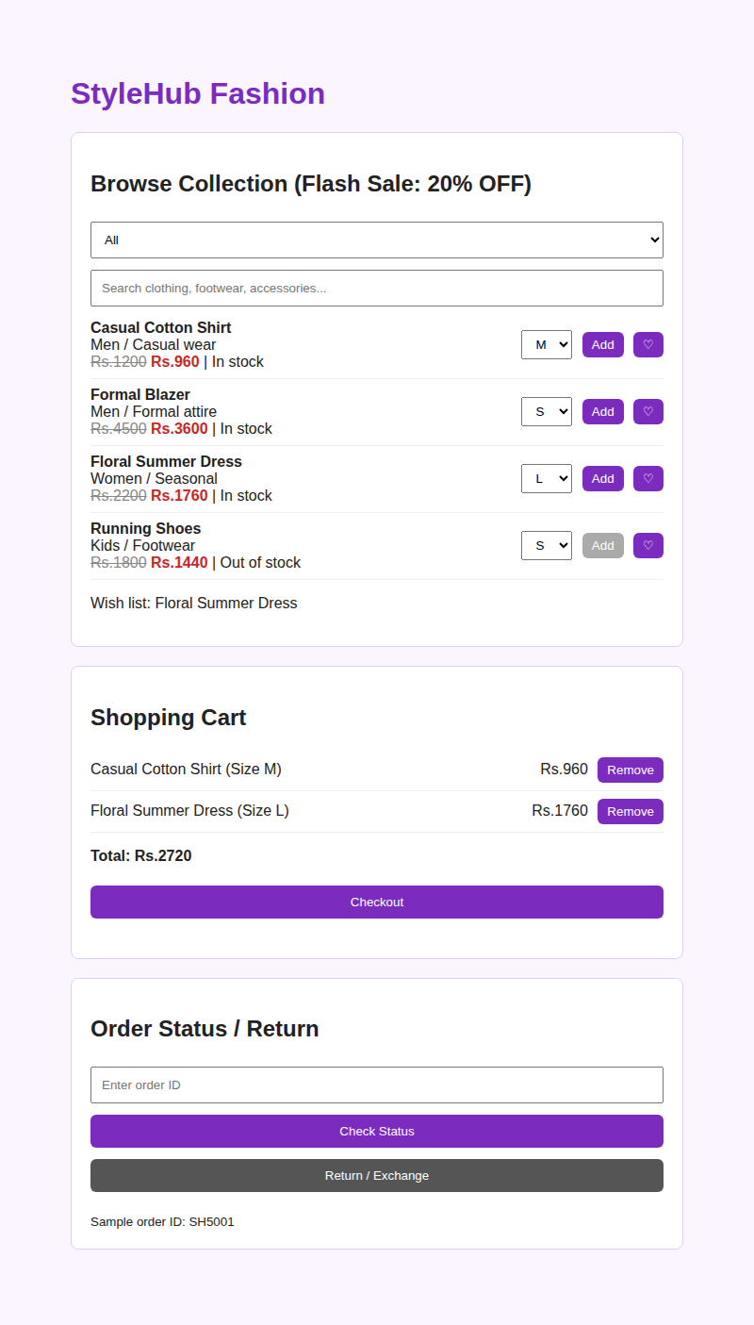  Output 1: Products listed and items added to cart | 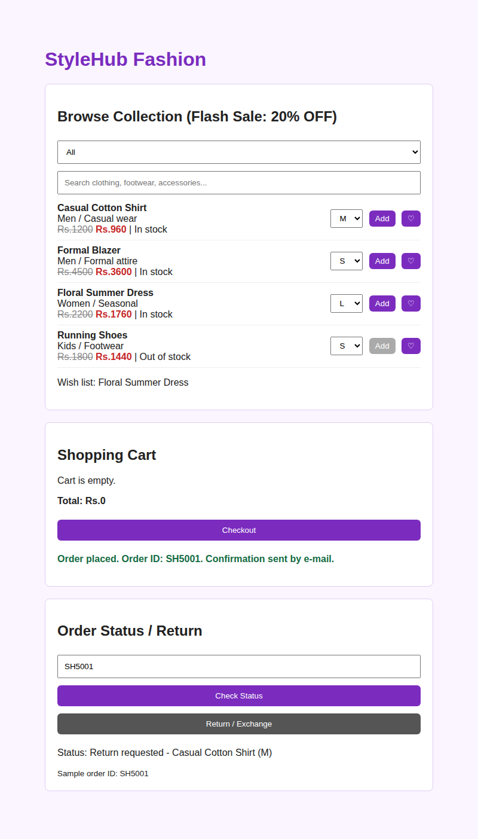  Output 2: Order placed and return requested
RESULT
The Online Fashion Store webpage was created successfully. It filters products by category and search text, applies the 20% flash-sale price, manages the cart with size selection and a wish list, places an order with a confirmation message, and shows the status or return request of the sample order ID SH5001.

